9th International Workshop on "Microwave Discharges: Fundamentals and Applications"
September 7-11, 2015, Cordoba, Spain
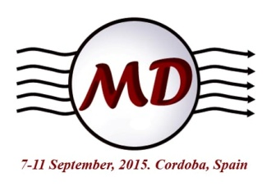
Registration and Accommodation Forms (MD9)
All attendants are requested to register by June 1.
Registration can be made on this registration form and the completed
form must be sent by e-mail to: md-9@uco.es , together with a duplicate
of the bank transfer invoice.

Participant | Prof. Dr. Mr. Ms.
 | Family Name | First Name |  | Middle Initial
Mailing Address | Affiliation (Dept., Univ. or Company)
 | Address
 | Postal/ZIP Code | Country
 | E-mail
 | TEL (include country and area code) |  | FAX (include country and area code)
Accompanying  Person(s) | Prof. Dr. Mr. Ms. |  | Single room Twin room
 | Family Name | First Name |  | Middle Initial
 | Prof. Dr. Mr. Ms. |  | Single room Twin room
 | Family Name | First Name |  | Middle Initial

Registration Fee | Category | Fee | No. of Persons | Amount to be Paid
 | Regular | 600/690 € |  | €
 | Student | 480/550 € |  | €
 | Accompanying person | 415/475 € |  | €
 | TOTAL |  |  | €
To complete workshop registration, please make payment of total registration fee by bank transfer.
Payment must be free of bank charges in transfer.
Bank Transfer
Bank name: Banco Santander
Account name: MD9 Local Organizing Committee (Gamero)
Bank address: Cr. Madrid-Cadiz, Km 397, S-N , Cordoba, Spain.
IBAN: ES67 0049 6710 4621 9024 1130
SWIFT: BSCHESMM
Reference of payment: Participation in MD-9, Name of participant.

